To use a button in an input group use input-group-btn class instead of input-group-addon class.   
bootstrap input group button

<div class="input-group">

    <input type="text" class="form-control"/>

    <span class="input-group-btn">

        <button class="btn btn-default" type="button">Search</button>

    </span>

</div>

**Using a button dropdown in an input group**   
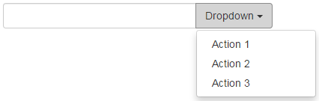

<div class="input-group">

    <input type="text" class="form-control"/>

    <div class="input-group-btn">

        <button type="button" data-toggle="dropdown"

                class="btn btn-default dropdown-toggle">

            Dropdown

            <span class="caret"></span>

        </button>

        <ul class="dropdown-menu">

            <li><a href="#">Action 1</a></li>

            <li><a href="#">Action 2</a></li>

            <li><a href="#">Action 3</a></li>

        </ul>

    </div>

</div>

Segmented buttons can also be added to the input element very easily as shown below. Notice we have a standard button along with a dropdown button appended on the right hand side of the input element.  
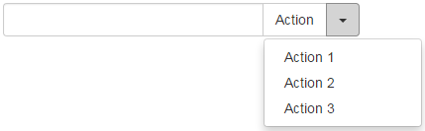

<div class="input-group">

    <input type="text" class="form-control"/>

    <div class="input-group-btn">

        <button type="button" class="btn btn-default">Action</button>

        <button type="button" data-toggle="dropdown"

                class="btn btn-default dropdown-toggle">

            <span class="caret"></span>

        </button>

        <ul class="dropdown-menu">

            <li><a href="#">Action 1</a></li>

            <li><a href="#">Action 2</a></li>

            <li><a href="#">Action 3</a></li>

        </ul>

    </div>

</div>

Multiple buttons can also be added to the input element.   
bootstrap input group multiple buttons

<div class="input-group">

    <input type="text" class="form-control"/>

    <div class="input-group-btn">

        <button type="button" class="btn btn-default">Cut</button>

        <button type="button" class="btn btn-default">Copy</button>

        <button type="button" class="btn btn-default">Paste</button>

    </div>

</div>

Multiple buttons with icons added to the input element  
bootstrap input group button icon

<div class="input-group">

    <input type="text" class="form-control"/>

    <div class="input-group-btn">

        <button type="button" class="btn btn-default">

            <span class="glyphicon glyphicon-align-left"></span>

        </button>

        <button type="button" class="btn btn-default">

            <span class="glyphicon glyphicon-align-center"></span>

        </button>

        <button type="button" class="btn btn-default">

            <span class="glyphicon glyphicon-align-right"></span>

        </button>

    </div>

</div>